**Thanh Nguyen**

**Student ID:** 101354326

Load Testing on Web Application

Final Testing Report

Semester 2, 2019

Table of Contents

[1. Executive Summary 2](file:///C:\Users\thanh\Desktop\PerfTestPlanResultsTemplate.docx#_Toc420668192)

[2. Context and Background 3](file:///C:\Users\thanh\Desktop\PerfTestPlanResultsTemplate.docx#_Toc420668194)

[2.1 Introduction 3](file:///C:\Users\thanh\Desktop\PerfTestPlanResultsTemplate.docx#_Toc420668195)

[2.2 Testing Process 3](file:///C:\Users\thanh\Desktop\PerfTestPlanResultsTemplate.docx#_Toc420668197)

[3. Performance Requirements and Planning 4](file:///C:\Users\thanh\Desktop\PerfTestPlanResultsTemplate.docx#_Toc420668206)

[3.1 Requirements 5](file:///C:\Users\thanh\Desktop\PerfTestPlanResultsTemplate.docx#_Toc420668207)

[3.2 Test Approach 6](file:///C:\Users\thanh\Desktop\PerfTestPlanResultsTemplate.docx#_Toc420668207)

[3.3 Assumptions and Constraints 6](file:///C:\\Users\\thanh\\Desktop\\PerfTestPlanResultsTemplate.docx" \l "_Toc420668207)

[3.3.1 Assumptions 6](file:///C:\Users\thanh\Desktop\PerfTestPlanResultsTemplate.docx#_Toc420668207)

[3.3.2 Constraints 6](file:///C:\Users\thanh\Desktop\PerfTestPlanResultsTemplate.docx#_Toc420668207)

[4. Performance Test Results and Analysis 7](file:///C:\Users\thanh\Desktop\PerfTestPlanResultsTemplate.docx#_Toc420668206)

[4.1 Performance Test Environment 7](file:///C:\Users\thanh\Desktop\PerfTestPlanResultsTemplate.docx#_Toc420668207)

[4.2 Test Run Scenario 7](file:///C:\Users\thanh\Desktop\PerfTestPlanResultsTemplate.docx#_Toc420668207)

[4.3 Performance Test Load 8](file:///C:\Users\thanh\Desktop\PerfTestPlanResultsTemplate.docx#_Toc420668207)

[4.4 Performance Test Scripts 8](file:///C:\Users\thanh\Desktop\PerfTestPlanResultsTemplate.docx#_Toc420668207)

[5. Performance Test Results and Analysis 10](file:///C:\Users\thanh\Desktop\PerfTestPlanResultsTemplate.docx#_Toc420668206)

[5.1 Performance Test Results and Analysis 10](file:///C:\Users\thanh\Desktop\PerfTestPlanResultsTemplate.docx#_Toc420668207)

[5.1.1 Test Run 1 – Baseline 14 minutes – by Jmeter 10](file:///C:\Users\thanh\Desktop\PerfTestPlanResultsTemplate.docx#_Toc420668207)

[5.1.2 Test Run 2 – Baseline 20 minutes – by BlazeMeter 14](file:///C:\Users\thanh\Desktop\PerfTestPlanResultsTemplate.docx#_Toc420668207)

[6. Conclusion 17](file:///C:\Users\thanh\Desktop\PerfTestPlanResultsTemplate.docx#_Toc420668213)

[7. Reference 18](file:///C:\Users\thanh\Desktop\PerfTestPlanResultsTemplate.docx#_Toc420668213)

# **Executive Summary**

This paper is final report for Topics in Computer Science unit (COS40004) to explain the process of a Load Test to to test the Australian Vodafone website - <https://www.vodafone.com.au/>. The process includes clarifying the critera for the test, describing the testing scenario, testing load, testing scripts and analysing the test results.

Load testing is a kind of performance testing which determines a system's performance under real-life load conditions. The test scenario based on the behaviours of the Vodafone website’s users The test scenario is run two times with Jmeter and BlazeMeter respectively. In the first test run, by the high latency of transaction processing, the result shows the poor performance of the website. In the second test run, the high latency of transaction processing, the result indicates quick response of Vodafone website although the performance of Vodafone website is not stable due to the existing bottlenecks in transaction processing during the test. Therefore, it would be better if the Australian Vodafone website is improved to better performance and stable to handle all transaction in the peak hour traffic website.

# **Context and Background**

## **Introduction**

Driving growth in the e-commerce business requires the assurance in the performance of web applications. Therefore, executing the performance testing, a means of quality assurance, is critical to sustain the business growth. Load testing is one of the types of performance testing prefers to automated testing process to value the performance of an web application under their expected workload.

By putting the load on the web system, the load testing helps to assess how the website meets the customer expectations on two measures: stability and speed.

* Stability measures the percentage of time users can access the website. It is a key factor which impacts on the success of business transactions.
* Speed measures end-to-end response time to determine how user retrieve data. Speed is also an important factor because of its lead to delays and lost business opportunities.

## **Testing Process**

Jmeter Apache is used for recording the script and then the script will be run 2 times by Jmeter and BlazeMeter.

* Define the criteria.
* Create a dedicated Test Environment for load testing.
* Load Test Scenarios.
* Determine testing load, prepare the test script and test data
* First test Scenario execution with Apache Jmeter.
* Analyze the results of th first test run .
* Re-test with BlazeMeter.
* Analyze the results of the second test run .

# **Performance Requirements and Planning**

## **Requirements**

In this section, the performance metrics are selected and the requirements are set. The metrics of performance testing is set

* **Response time**: The time that passed to perform the request and receive full response. For user perpective, response time could be measured as the time between when the user clicks a button or a link and when the browser starts to display the resulting page. This is one of key aspects to define performance of a web application.

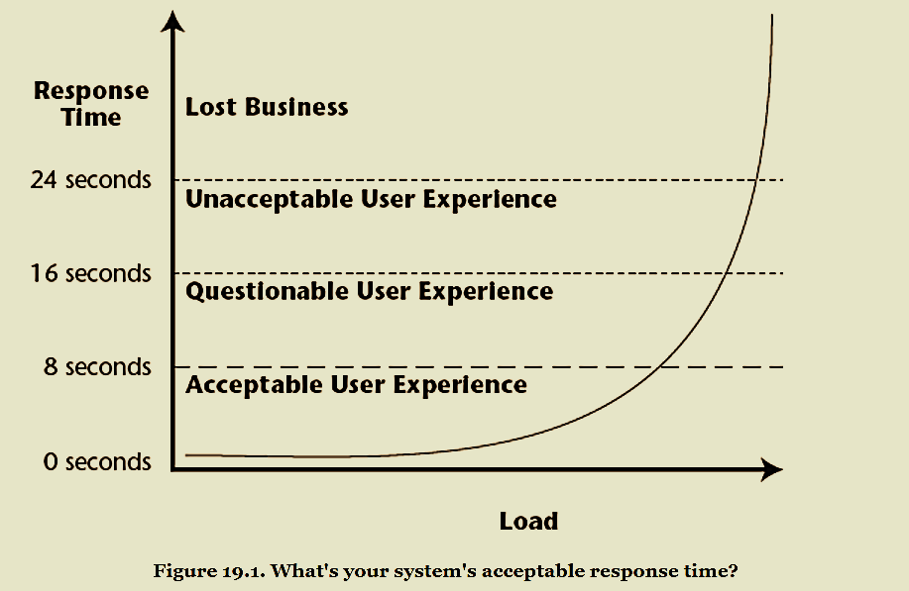

**Figure 1:** *The acceptable level of the transaction responsse time.*

Suppose a marketing survey is conducted and the findings show that, for the typical user:

* The transaction response time is of an acceptable level as long as it does not exceed 4s.
* If response time is between 4 to 8 seconds, 30% of users cancel their transactions.
* If response time is between 8 to 10 seconds, 60% of users cancel their transactions.
* If response time increases to over 10 seconds, over 90% of users cancel their transactions.
* **Error rates**: is number of problem requests compared to total requests and is the first important non-speed-related metric.
* **Throughput**: is calculated as requests/units/hits/transaction per second that the website can handle. If a web app receives 50 requests per second, but can only handle 30 transactions per second, the other 20 requests end up waiting in a queue. Therefore, throughput is the most important parameter to evaluate the performance of a website by helping identify maximum requests a website can handle and the point of a bottleneck due to which application starts degrading performance. It represents the ability of the server to handle a heavy load. The higher the throughput is, the better is the website performance.
* **Latency time**: (also called as **Time to First Byte**) is the time from simply sending out the request until the first byte of response is accepted. High latency points out networking problems.

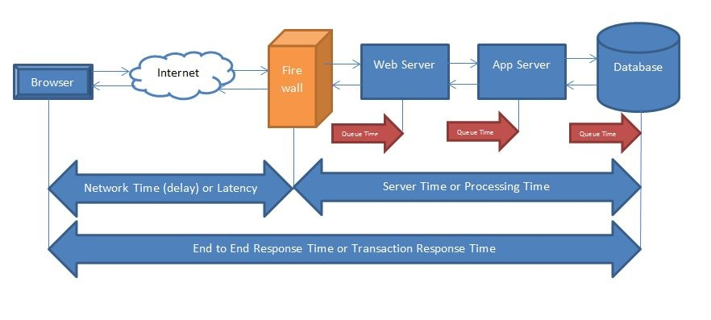

**Figure 2:** *Time meassure of a request in performance testing.*

Because the latency time impacts on other aspects: response times and throughput, the latency time ensures the fairness of the evaluation of the performance testing. For the use of website, the latency time under 100ms is reasonable.

## **Testing Approach**

* Test Strategy: Load testing is automated testing and a type of performance testing. It is used to test the performance of Vodafone Website.
* Test Development:
* The test scenario and the requirements are defined in test plan.
* The testing environment is set up and record the test scripts.
* Test Execution:
* The test srcipts are run and the test result is return by the listenners.
* Test metrics and the final test report to analyse the the test result.

## **Assumptions and Constraints.**

### **Assumptions**

Testing environment: Vodafone website fully functioned.

### **Constraints**

The response time is impacted by Internet bandwidth, tools and servers which are used for testing.

The time and resource for running test is also limited. For using BlazeMeter free version, the testing time is allowed only under 20 minutes. However, using Apache Jmeter, the testing result can be impacted by the local Internet and the distance between the servers.

# **Performance Test Execution**

## **Performance Test Environment**

* Window testing flatform: window 10
* Tools: All sofware below are used for the test

- Java SE Development Kit 8

- Apache Jmeter 5.1.1

- Firefox browser (latest version).

- BlazeMeter

## **Test Run Scenario**

A load test is conduct to measure the performance of the Australian vodafone website (Vodafone.com.au) which is a secured (https) website. In this project, test scripts will be recorded by stimulation of the user’s behaviours of Vodafone website as table below:

|  |  |  |
| --- | --- | --- |
| **Scenario** | **Pages** | **Http Request Method** |
| Launch the homepage | Homepage | GET |
| Surfing news | About Vodaphone, Hot Offers, Phone Plans, Prepaid Plans, Bundle news, Support Service | GET |
| Login and Log out | LoginToMyVodafone, VodafoneLoginPage, MyVodafone Page, Usage history, Purchase History, Logout | GET and POST |

**Table 1:** *Scenario to record scripts for Australian Vodafone Website Testing.*

After the test script is recorded by using Apache Jmeter, the scripts will be run two times by Jmeter and BlazeMeter to get the test result and analyze it.

## **Performance Test Load**

In this scenario, the test will be run with 10 virtual users at the same time (ramp-up at 1 second: all user will run after 1 second in the test). They will launch the Australian Vodafone website, surf news and login, log out as the table 1 described.

## **Performance Test Scripts**

Apache Jmeter is used to record the scripts which are decribed as table 2 and figure 3 below:

|  |  |  |
| --- | --- | --- |
| Step | Transactions | Describe |
| 1 | Lauch Vodafone Hompage | Enter URL <https://www.vodafone.com.au/> to view Homepage |
| 2 | Viewing pages:   * AboutVodaphone * Hot Offers * Phone Plans * Prepaid Plans * Bundle news * Support Service | Enter URL addrress of those pages or click those pages to access and view information |
| 3 | Access MyVodafoneLogin | Click on Login to MyVodafoneLogin to go: https://www.vodafone.com.au/my-vodafone |
| 4 | Click on the ‘Login Now’ button in MyVodafoneLogin page | After click on ‘Login Now’ button, user will go to https://auth.myvodafone.com.au/login?code=uxr |
| 5 | Enter username & password and click on ‘Login’ button | Go to the account’s homepage to view account balance  https://myaccount.myvodafone.com.au/ |
| 6 | Click on ‘View History” => “Usage History” | Go to <https://myaccount.myvodafone.com.au/usage> to view the Usage History |
| 7 | Click on ‘View History” => “Purchase History” | Go to <https://myaccount.myvodafone.com.au/purchase> to view the Purchase History |
| 8 | Logout | Click on Logout https://myaccount.myvodafone.com.au/signout |

**Table 2:** *Script Details to record for Australian Vodafone Website Testing.*

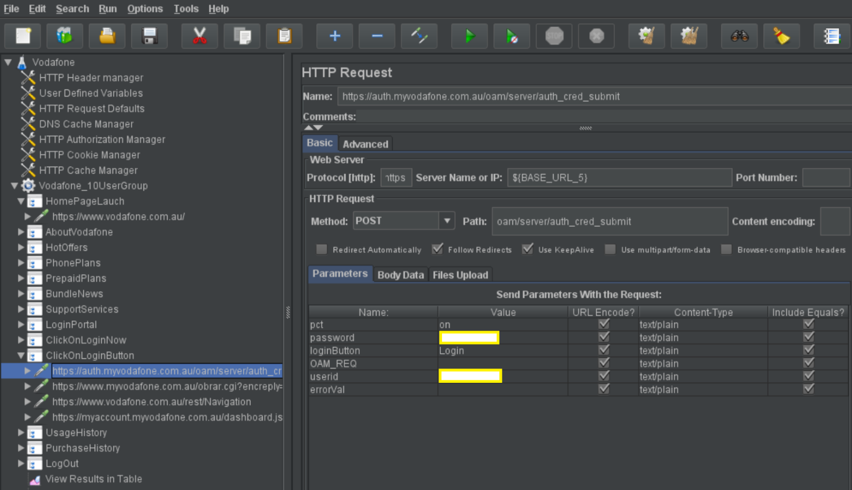

**Figure 3:** *Recorded scripts of https for Australian Vodafone Website Testing.*

# **Performance Test Results and Analysis**

## **Performance Test Results and Analysis**

#### Test Run 1 – Baseline 14 minute – by Apache Jmeter

In this first load test run, Apache Jmeter is used to send a load on the Australia Vodafone website by using the created scripts and get the testing results by the listeners.

The test run and completed in about 14 minutes, seen as figure 4 below. It is about 10 virtual users that active at same time (ramp up at 0 second) and do the tasks that test scripts described.

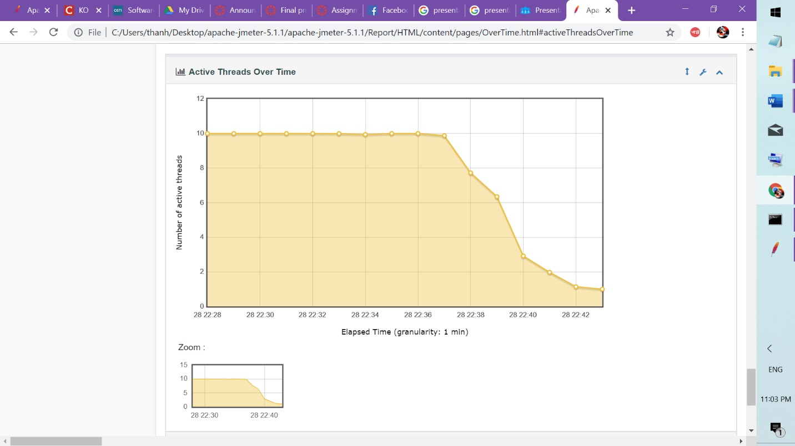

**Figure 4:** *The number of active user during the test run 1.*

* **Respond Time**.
* **Error rates.**
* The average reponse time of 4228 transactions is less than or equal 0.5 second.
* The average reponse time of 974 transactions is between 0.5 and 1.5 second.
* The average reponse time of 634 transactions is more than 1.5 second.
* There are 4 transactions in total of 5840 transaction reponse (0.07%) is in errors

The respond time is not acceptable and fairly slow due to some transaction is over 4 seconds ( seen as figure 5 below and in sumary report in delivery).

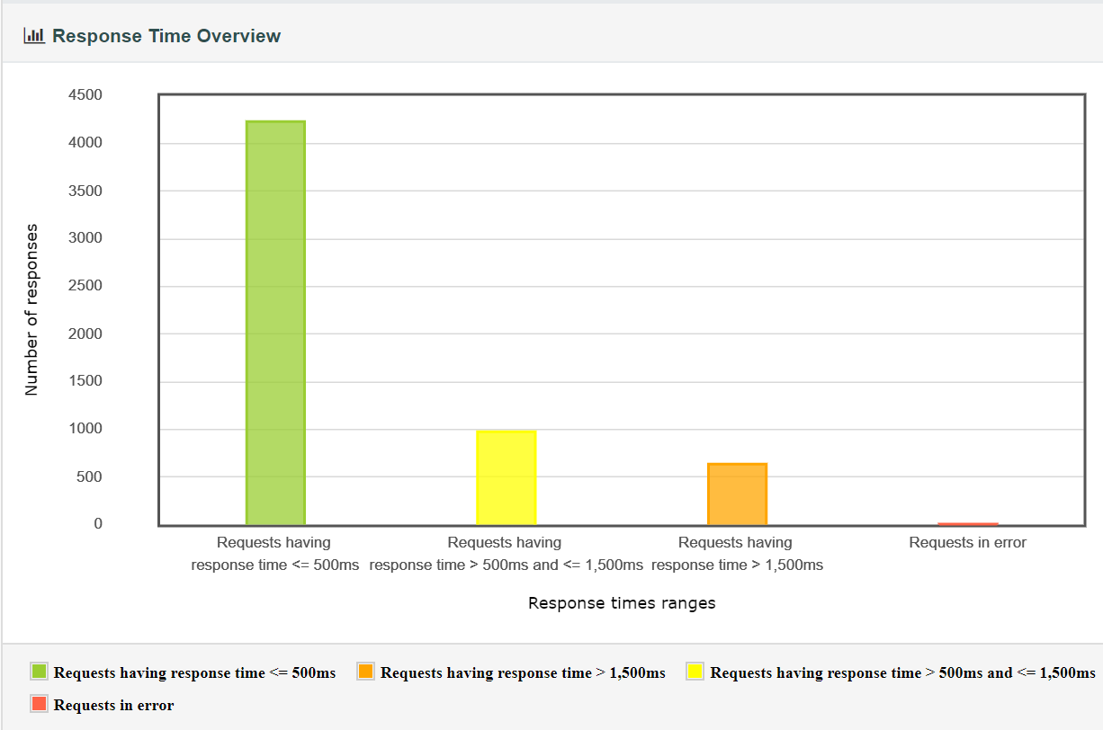

**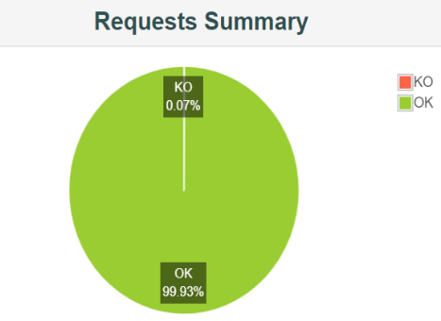**

**Figure 5:** *The number of response in time range during the test run 1.*

* **Throughput**

In the scenario of this load test, all 10 concurrent users are doing work, the throughput is expected to stay fairly consistent. But in fact, the throughput plummets and it present the bottlenecks seen as figure 6 below. In this test run, the best time point is 28 20:38 when the Vodafone website can handle about 12.08 requests per second.

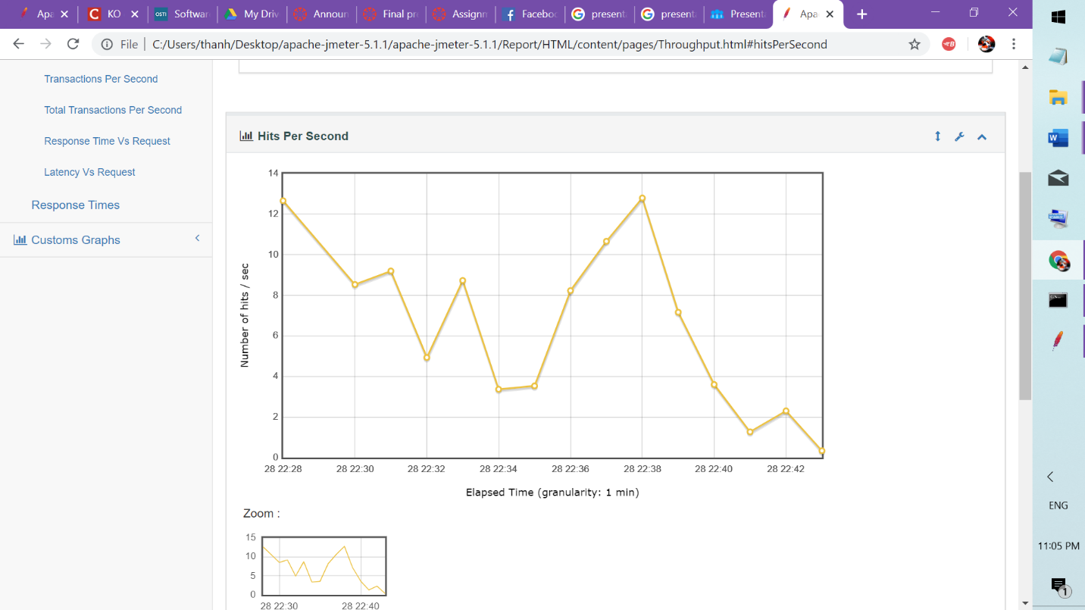

**Figure 6:** *The throughput during the test run 1.*

* **Latency**

The figure 7 shows that there is problems with the connections between servers in this test run because the average latenies is fairly high. There are times when the latency reachs over 1000ms and that is unreasonable for the test run, not ensure the test fairness and highly impact on the realibility of the test result. The cause of high response latency can be due to reasons:

* The network is not good and stable to run the test
* The distance between the servers (Jmeter and Vodafones): distance will result the long response.

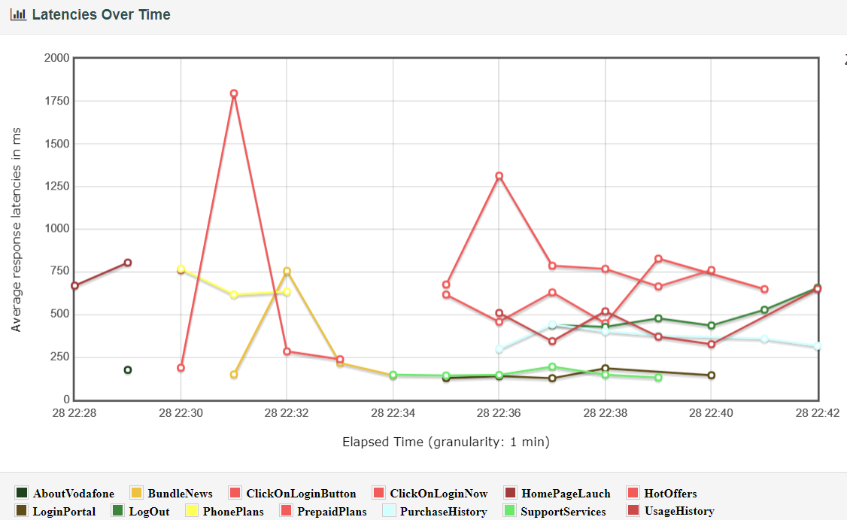

**Figure 7:** *The average latencies during the test run 1.*

* **Test Result:** In th defined scenario, the result of this test run indicates poor performance of Vodafone website due to the slow response, existing errors, the bottlenecks in transaction processing. However, due to the latencies of response in the test, the result of this test run is not fairness and realiable result.

#### Test Run 2 – Baseline 20 minute – by BlazeMeter

In this second load test run, BlazeMeter is used to send a load on the Australia Vodafone website by using the created Jmeter scripts.

The test is run in about 20 minutes, seen as figure 8 below. It is about 10 virtual users that active at same time after 1 second (ramp up at 1 second) and do the tasks that test scripts described.

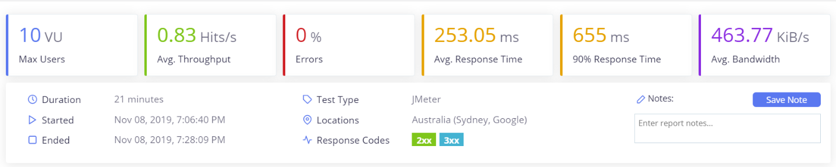

**Figure 8:** *The average latencies during the test run 2.*

* **Response Time**

The average response time of a transactions is about 15 second (253 ms) and the max response time in this test run is about 2 second (2239 ms) during the time that 10 concurrence users are active. It is a acceptable result (all transaction below 4 seconds) as can seen in the figure 8, 9 and table 3.

|  |  |  |  |
| --- | --- | --- | --- |
| Transaction | Request | Avg. Response Time | Max Res. Time |
| 1 | ClickOnLoginButton | 1543.93 ms | 2239 ms |
| 2 | HomePageLaunch | 1008.57 ms | 3167 ms |
| 3 | ClickOnLoginNow | 908.69 ms | 1631 ms |
|  |  |  |  |

**Table 3:** *Top 3 slowest response (by avg. response time) in the test run 2.*

* **Error Rates**

No errors is found in this second test run.

* **Throughput**

The green line in the figure 9 below is not as flatline and shows the plumets and rapid drops in the average throughput, that means that there are the bottlenecks in the transaction processing.

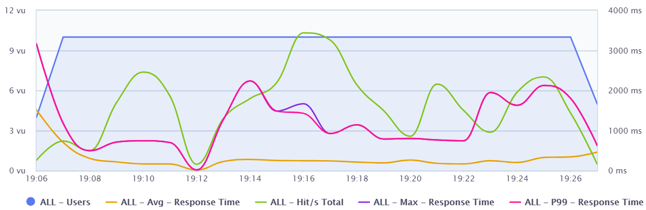

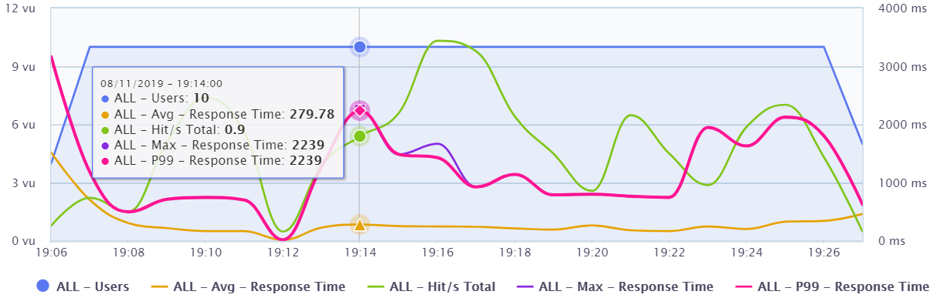

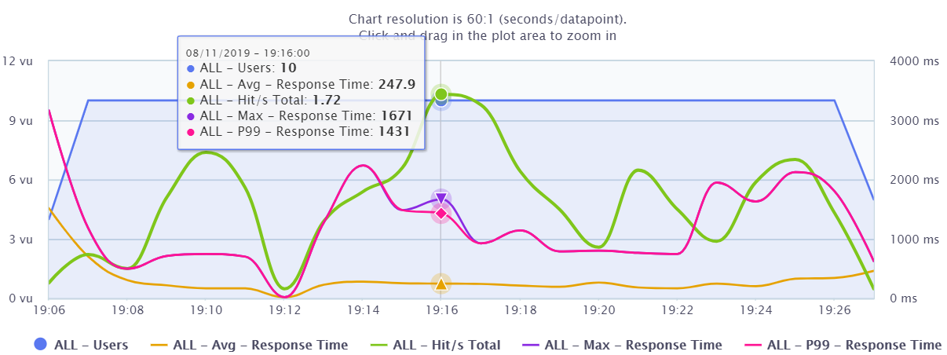

**Figure 9:** *The average, max response time and throughput during the test run 2*

* **Latency:**

The latency in this second test run is stable and fairly low. The latency in all transaction is less than 200ms as seen in the figure 10 below. Therefore, the result of this test run is reliable and less impacted by the factors such as: network traffic, the connection or distance between severs.

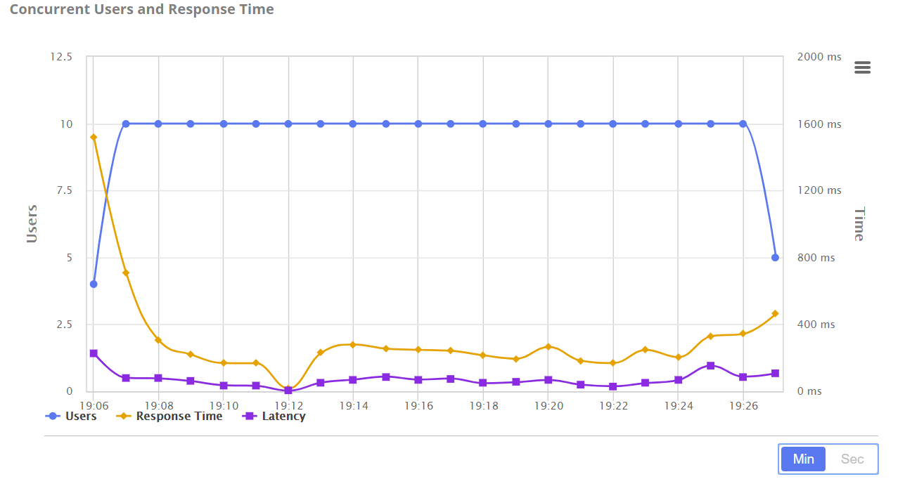

**Figure 10:** *The response time and latency during the test run 2*

* **Test Result:** In the defined scenario, the result of this second test run indicates quick response of Vodafone website although the performance of Vodafone website is not stable due to the existing bottlenecks in transaction processing during the test. This result is reliable and less impacted by factors including: the network traffic, the connection or distance between severs.

# **Conclusion**

This paper explains the process of a Load Test, clarifies the critera for the test, describes the testing scenario, testing load, testing scripts and analyse the test results. The test scenario is run two times with Jmeter and BlazeMeter respectively. In the first test run, by the high latency of transaction processing, the result shows the poor performance of the website. In the second test run, the high latency of transaction processing, the result indicates quick response of Vodafone website although the performance of Vodafone website is not stable due to the existing bottlenecks in transaction processing during the test. Therefore, it would be better if the Australian Vodafone website is improved to better performance and stable to handle all transaction in the peak hour traffic website.

# **Reference**

Hung, Q N, Bob, J & Michael, H 2003, *Testing Applications on the Web: Test Planning for Mobile and Internet-Based Systems*, Second Edition, John Wiley & Sons.

Rodrigues, A G, Bruno, D, & Philippe, M 2019, *Master Apache JMeter - from Load Testing to DevOps : Master Performance Testing with JMeter*, Packt Publishing.

User’s Manual, *Apache Jmeter*, viewed 1 Oct 2019, <<https://jmeter.apache.org/usermanual/>>.